**INTERNATIONAL STUDENT HANDBOOK**

*INTERNATIONAL STUDENT PROGRAM*



Brunswick Secondary College acknowledges the Wurundjeri people of the Kulin Nations, the traditional owners of the land and waters upon which our school stands.

Brunswick Secondary College is accredited under the

Department of Education CRICOS registration

CRICOS provider name - Department of Education, Code - 00861K

For further information refer to [www.study.vic.gov.au](http://www.study.vic.gov.au)

Contents

1. About Our School 4

1.1. Visions and values 4

2. School Details 5

2.1. School Information 5

2.2. Direction to Brunswick Secondary College via public transportation 5

2.3. School Map 5

3. Our Team 6

4. Emergency Contacts 6

5. International Student Program 7

5.1. Support on Arrival 7

5.2. Enrolment and Orientation 7

5.3. Local Buddy Program Support 8

5.4. Attendance Policy 8

5.5. Course Progress Policy 8

5.6. Behaviour Policy 8

5.7. Travel Policy 8

5.8. Homestay Policy 9

5.8.1. Homestay agreement 9

5.9. Overseas Student Health Cover (OSHC) 9

6. Life in Melbourne 10

6.1. Melbourne’s Weather 10

6.2. Public transport 10

6.2.1. PTV School Student Pass 10

6.2.2. Taxis 10

6.3. Banking 10

6.4. Healthcare system 11

6.5. Telephone/Mobile 11

6.6. Brunswick Local Area 11

6.6.1 Shopping 12

6.7. Workplace rights and protections 12

7. Studying at Brunswick Secondary College 13

7.1. School term dates and holidays 13

7.2. School timetable 13

7.3. School Resources 14

7.3.1. Library 14

7.3.2. Bocca Café- Online lunch order 14

7.3.3. First Aid 14

7.3.4. Uniform shop 14

7.3.5. Booklists & Stationary 14

7.3.6. Lockers and padlocks 14

7.4. Student Wellbeing 15

7.4.1. Wellbeing team 15

7.4.2. Home groups 15

7.4.3. Co- Curriculum Program 15

7.5. Careers & Learning Pathways 16

7.5.1. Subject Selection 16

7.6. School facilities 17

7.7. School policies and documents library 17

7.8. The House System 18

7.9. BYOD and Computer Services 18

7.9.1. Bring your own Device (BYOD) Program 18

7.9.2. Computer services 18

7.10. Tuition fee and other payments 19

7.10.1. Tuition fee 19

7.10.2. VCAA 19

8. Other useful websites 19

Studying in Melbourne & FAQ 19

Australian ALL IN ONE in Chinese 19

International Student Visa Condition 19

Melbourne life 19

Merri-bek City Council 19

Child Safety 1

Legal services (advice) 1

Children **&** PedestrianSafety 1

# About Our School

Brunswick Secondary College has an overall enrolment of approximately one thousand students. The majority of students reside in Brunswick with a smaller number of students from outside the Brunswick area. The school has a Select Entry Accelerated Learning Program with an intake at Year 7 and an International Student Program.

Supporting high academic standards is an emphasis on positive relationships and community. This places a strong value on student feedback to their teachers. There are diverse opportunities for parental involvement, student leadership and a rich array of extra-curricular activities. In our school the six values of teamwork, respect, excellence, achievement, persistence, and responsibility underlie all relationships, planning and activities within the college.

At Brunswick Secondary College, we strive continually to provide the highest standards of student engagement and learning so that we can continue to be regarded by the Brunswick community as an excellent choice for its students. Brunswick Secondary College’s success can be measured by the steady increase in enrolment, reputation and results that has occurred over the past decade and through data analysis demonstrating a strong value-add to learning.

At Brunswick Secondary College we provide an environment that promotes personal growth and learning in our students, challenging, and encouraging them all to realise their individual potential. We are committed to the development of young people who live successful and constructive lives, with positive personal values and a strong sense of community.

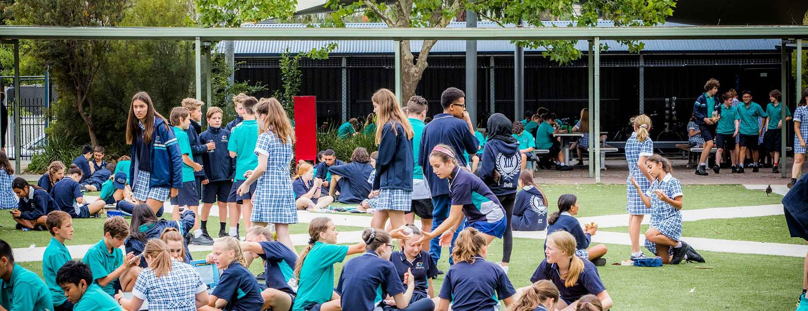

## Visions and values

Our school fosters a culture that promotes the values of **Teamwork, Persistence, Responsibility, Achievement,**and **Excellence**, founded on the core value of **Respect**.

In achieving our vision, Brunswick Secondary College will reflect the aspirations of our community, providing opportunities for our students to become leaders in their world. This is how the staff and students of Brunswick Secondary live these values every day.

# School Details

## School Information

Address: 47 Dawson St, Brunswick VIC 3056

Phone: (03) 9387 6133

Fax: (03) 9387 0061

Office hours: 8.30 AM – 4.00 PM

Administration Email: [Brunswick.sc@education.vic.gov.au](mailto:Brunswick.sc@education.vic.gov.au)

ISC Email: [CZHO@brunswick.edu.vic.au](mailto:CZHO@brunswick.edu.vic.au)

Website: [www.brunswick.vic.edu.au](http://www.brunswick.vic.edu.au)

## Direction to Brunswick Secondary College via public transportation

The following transport lines have routes that pass near Brunswick Secondary College.

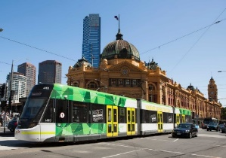To access travel options, consider installing the PTV app on your phone.

* Bus: #504, #506
* Train: Upfield Train Line
* Tram: #19, #58

## School Map

Bus

Sydney Road

Train, Tram

# Our Team

| **Role** | | **Name** | **Email** |
| --- | --- | --- | --- |
| Principal Team | Principal | Karen Harris | KHAR@brunswick.vic.edu.au |
| Assistant Principal | Sally Goss | SGOS@brunswick.vic.edu.au |
| Assistant Principal | Tas Michael | TMIC@brunswick.vic.edu.au |
| Assistant Principal | Sam Milbourn | SMIL@brunswick.vic.edu.au |
| Assistant Principal | Claudia Johnson | CJOH@brunswick.vic.edu.au |
| Senior School | Senior School Leader | Simone Vukotic | SVUK@brunswick.vic.edu.au |
| Year 12 Coordinator | Tayler Roberts | TROB@brunswick.vic.edu.au |
| Year 11 Coordinator | Rosalie Fourniotis | RFOU@brunswick.vic.edu.au |
| Year 11 Coordinator | Mark Haebich | MHAE@brunswick.vic.edu.au |
| Administration & VET Adv | Penny Moffat | PMOF@brunswick.vic.edu.au |
| Middle School | Middle School Leader | Derek Glennie | DGLE@brunswick.vic.edu.au |
| Year 9 CooVictoriardinator | Sam Hall | SHAL@brunswick.vic.edu.au |
| Year 9 Coordinator | Victoria Austin | VAUS@brunswick.vic.edu.au |
| Year 10 Coordinator | Sheridan Dinsdale | SDIN@brunswick.vic.edu.au |
| Junior School | Junior School Leader | Tamara Ghazale | TGHA@brunswick.vic.edu.au |
| Year 7 Coordinator | Barbara Moss | BMOS@brunswick.vic.edu.au |
| Year 8 Coordinator | Michelle O’Brien | MOBR@brunswick.vic.edu.au |
| Year 8 Coordinator Asst | Chloe Willmott | CWIL@brunswick.vic.edu.au |
| Student Wellbeing | Student Wellbeing Leader | Sarah Rogers | SROG@brunswick.vic.edu.au |
| Mental Health Practitioner | Jacinta Vengtasamy | JVEN@brunswick.vic.edu.au |
| Student Wellbeing | Ross Mortimer | RMOR@brunswick.vic.edu.au |
| Student Wellbeing | Kathy Serratore | KSER@brunswick.vic.edu.au |
| Student Wellbeing | Jacqui Pasinis | JPAS@brunswick.vic.edu.au |
| School Nurse | Jeremy Fiske | JFIS@brunswick.vic.edu.au |
| Careers & Pathways | Career Counsellor | Laura Hughes | LHUG@brunswick.vic.edu.au |
| Library | Librarian | Jennifer Easson | JEAS@brunswick.vic.edu.au |
| Library Assistant | Anna Gillon | DALL@brunswick.vic.edu.au |
| General Office | International Student Coordinator | Chelsea Zhou | CZHO@brunswick.vic.edu.au |
| Student Administration | Sheila Calwell  Caroline Farah | studentadmin@brunswick.vic.edu.au |
| IT support | Gus Dobricic | GDOB@brunswick.vic.edu.au |
| Helen Stratopoulos | HSTR@brunswick.vic.edu.au |
| Executive Assistant | Lindel Bell | LBEL@brunswick.vic.edu.au |
| EAL | EAL Leader | Antoinette Siciliano | ASIC@brunswick.vic.edu.au |

# Emergency Contacts

**International Student Emergency Card** is issued on your orientation day. Please keep this with you at all the time. On the card, you will find the following information:

* Your student ID numbers
* Your current homestay’s address
* Emergency number (police, fire, ambulance): 000
* School contact information
* ISP contact number after school – Chelsea Zhou: 0431 677 188
* DET is regulated by the Victorian Registration & Qualifications Authority (VRQA).

Students can contact: [www.vrqa.gov.au](http://www.vrqa.gov.au)

**Emergency, crisis, and support services are available at all times and in all locations. Dial: 112 (from mobile, even if you have no signal or network connection).**

You also can download the Emergency+ application (app) from the Apple, Google and Android. The Emergency+ app helps provide critical location to emergency services

# International Student Program

At Brunswick, we understand the challenges that international students may face, especially at the beginning of their study’s journey. That is why the International Student Team are here to guide you with your studies and support you from your pre-arrival time to after your graduation from Brunswick Secondary College.

The International Student Coordinator, Ms. Chelsea Zhou is your main point of contact for support at school. **Please don’t hesitate to reach out for help if you have any concerns about study, homestay, or personal life**. Ms. Chelsea Zhou works closely with the Principal Team, year level leaders and other education support staffs to ensure that your academic and wellbeing needs are closely monitored.

The International Student Program has special programs which are designed only for you including:

* - International students’ orientation activities
* - Local Buddy Support Program
* - Leadership programs and opportunities for international students
* - Extra academic support for international students at EAL support group and Homework club
* - Weekly mentoring and welfare sessions with International Student Coordinator
* -International students catch up events such as 18th, termly lunch activities, and multicultural celebration (i.e., Lunar New Year, Mid-Autumn festival, Dragon Boat Festival…)

## Support on Arrival

For international student, whose welfare belong to the *school (option 3 nominated homestay & option 4 school arranged homestay),* your parents or education agent will be required to complete the Department’s Flight Details Form and send it with an English copy of your plane ticket to the Department four weeks before you expect to arrive in Australia. The Department is not responsible for your welfare more than **seven days** before your studies commence. Please do not arrive at your homestay before this time.

For homestay student, when you arrive in Melbourne, the school International Student Coordinator (ISC), arranged school staff or homestay family will be at the airport to greet you and transfer you to your homestay*. You can also require for onshore transfer, e.g., hotel to homestay. ISC will introduce you to your homestay and provide homestay induction to ensure you have a smooth transition at the new environment.

You will receive an Arrival Support From before you leave your home country. This will include:

* The school ISC’s name, photo, and contact number
* Photos of the airport meeting point
* Emergency contact details

* Please be aware, your ISC is not responsible for the transport of any additional persons (including family members) to your homestay.

## Enrolment and Orientation

ISP orientation day event is organised for only international students before their studies commence. On the day, your Year Level Coordinator will show you around the school and help you with uniform and book purchasing. You will have an opportunity to meet your International Student Coordinator, go through your enrolment paperwork and participate in our ISP orientation student activities.

It is vital you submit all your necessary documents before you start school. Please ensure you have your passport and visa on your orientation day. You will have your photo taken for Student ID card in the general office. Please also remember to bring your laptop with you for laptop setup and network connection prior to your first day. 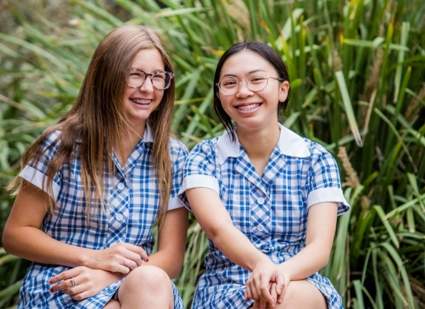Your ISC will go through the orientation slides with you and give you time to read the school’s policy and other important documents.

## Local Buddy Program Support

The Student Mentor program is designed to foster meaningful friendships between new commencing international students and existing students, to facilitate a smooth transition into Melbourne culture and college life. You will have an opportunity to connect with your buddy and other peers at school on your first day of school. Besides your International Student Coordinator and teachers, your buddy is here to help you finding your way around the school, serve as a “go-to” person for any questions, concerns about school.

## Attendance Policy

Brunswick Secondary College requires all international students to attend 100% of their classes, assemblies, and activities, as a condition of Enrolment. Absences are to be satisfactorily explained, by email or phone call from the student’s designated carer or homestay for a short absence, or by a medical certificate for an absence. Any absences longer than five (5) consecutive days without approval will be investigated by the school. School will have intervention strategy for students who cannot reach at least 90% attendance rate. Student, parents, or legal custodian will be notified can be for absence reasons. Student may be given detention from their year level teachers.

International students have very strict attendance requirements tied to their visa conditions. Students whose attendance rate below 85% would receive 1st Attendance Contract and 2 weeks observation for improving; if the student breaks the contract, 2nd contract will be given - the *Principal Contract*. When the attendance rate is below 80%, students will put their visa at risk and will be reported to the Department of Education and Training for breach of International Student Policy.

## Course Progress Policy

School assesses a student’s performance each term using the requirements set by the Victorian Curriculum and Assessment Authority, which is same for domestic students. All subjects/units must be completed satisfactorily within the expected duration as specified on the student’s C for the student to progress to the next year level or complete the course of study.

Students requiring assistance with their performance will be counselled. Counselling will include suggestions for improving performance such as additional support for the subject specific tutoring. Course progress agreement between the student and the school may be developed to assist with improving performance. If the performance agreement does not meet, the student will be reported to DIBP for non-compliance with visa conditions.

## Behaviour Policy

Brunswick Secondary College is committed to develop a positive, safe, supportive learning environment for students and staff, where students have opportunities to engage in quality learning experiences and acquire support of their lifelong wellbeing. Please view the details of [Schoolwide Positive Behaviours - Brunswick Secondary College](https://www.brunswick.vic.edu.au/student-wellbeing/swpb/) on the school website. Implementation of SWPBS ensures that teachers and students have more time to focus on relationships and classroom instruction.

Students must also be aware of DIBP visa conditions to ensure that they are compliant at all times. If this Student Behaviour Policy is breached, the IED may report the student to DIBP for non-compliance with visa conditions.

## Travel Policy

International students need permission from parents or legal custodian before they wish to stay overnight in a different location either in Victoria or interstate. To get the overnight stay approval, you will need to complete the ***ISP Overnight Stay/Travel Permission Form*** and provide the following requirements to your International Student Coordinator:

* Written approval from your parents/legal custodian
* Approval from the school Principal/Assistant Principal
* If you are living in a homestay, you need to let your homestay know the details of your travel arrangements.

You are also required to inform your International Student Coordinator your travel plan during school holiday. If you travel overseas, your parents will have to email a written approval with your flight itinerary to your ISC.

## Homestay Policy

Brunswick Secondary College requires all International Students whose welfare belong to the school irrespective of age, to obtain homestay accommodation approved by the school. Students are not permitted to live independently or without adult supervision. The International Student Coordinator will regularly monitor your homestay agreement. We encourage you to respect your homestay and work together to discuss household rules, customs, and expectations. If you are having problems with your host family, please talk to your International Student Coordinator.

Homestay policy is updated yearly on the [Brunswick Secondary College website](https://www.brunswick.vic.edu.au/our-school/policies-documents/)

### Homestay agreement

You are expected to behave as a contributing member of the household and obey the homestay rules on the Homestay Responsibility Agreement on arrival.

If your parents are visiting Melbourne and your family would like to stay together, please contact ISC to ask for permission. You may only stay with your parents if this is approved by the school.

## Overseas Student Health Cover (OSHC)

OSHC is insurance to assist Overseas students meet the costs of (Public) medical and hospital care that they may need while in Australia. OSHC will also pay limited benefits for pharmaceuticals and ambulance services.

Details and costs of policies, including what an OSHC policy will and will not cover, and any waiting periods that may apply to certain treatment types, can be obtained by contacting each insurer directly. OSHC is considered adequate health insurance, however, if you find your OSHC policy does not cover you for everything you want, you can take out additional private health/travel insurance. You should check with your OSHC provider website as the services and support provided can vary from provider to provider.

Common advice and support OSHC providers may provide include:

* medical assistance
* referral to a doctor for medical treatment
* counselling services
* family and friends messaging services in the event of an emergency
* personal safety

OSHC providers in Australia include:

* Australian Health Management (ahm) [www.ahmoshc.com.au](http://www.ahmoshc.com.au)
* Allianz [www.allianzassistancehealth.com.au](http://www.allianzassistancehealth.com.au)
* BUPA Australia [www.bupa.com.au](http://www.bupa.com.au)
* Medibank Private [www.medibank.com.au](http://www.medibank.com.au)
* NIB Health Funds Limited [www.nib.com.au/overseas-students](http://www.nib.com.au/overseas-students)

(*) Please note that international students need to provide your OSHC information include e-card copy with membership number and expired date to ISP for system records.

# Life in Melbourne

## Melbourne’s Weather

Melbourne can be known for its fickle weather - the city has been described as having four seasons in one day - but it can still be enjoyed all year round. Summer is from December to February, when temperatures can occasionally soar past 35 °C. Autumn is from March to May with average temperatures ranging from 10.9 – 20.3°C. Winter is from June to August with average temperatures range from 6.5 - 14.2°C. Spring is from September to November with average temperatures rage from 9.6 - 19.6°C.

## Public transport

Melbourne's public transport is the easiest and best way to get around the city. You can buy a *Myki smartcard* for flexible travel between trains, trams, and buses. Visit the website <https://www.ptv.vic.gov.au/> to find out about purchasing a Myki Card or download the Public Transport Victoria app on your phone. You will be able to look up the most updated timetable and find the quickest route to your destination.

### PTV School Student Pass

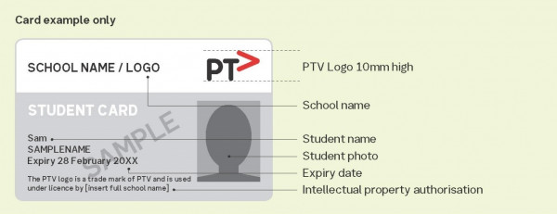School students can get public transport ticket discount by applying the PTV school student pass. Please [click here](https://www.ptv.vic.gov.au/assets/PTV-default-site/tickets/myki/concessions-and-free-travel/children-and-students/information-for-schools-on-ptv-approved-school-student-id/4e9dad8d9b/DS_2020-PTV-School-Student-ID-and-Student-Pass-application-form_1_June.pdf) to download the application form or get the hard copy at the general office. You will need to prepare 2 photos ID and fill in the form to get the approval in the general office. PTV approved school student ID card must be carried along with your myki when travelling.

### Taxis

Melbourne taxis are easy to spot, as they display a lamp on the cab roof and most are painted yellow, silver, or white. Drivers wear uniform and always show an identity card on the dashboard. Melbourne’s major taxi companies include:

* 13 CABS (Ph 13 22 27 – in Australia) [13cabs.com.au](https://book.13cabs.com.au/?gclid=EAIaIQobChMI7Z65rPWE_QIVrZlmAh0mEA8tEAAYASAAEgLBNfD_BwE)
* Silver Top Taxi (Ph 13 10 08 – In Australia) [silvertop.com.au](https://silvertop.com.au/)
* CABiT (Ph 13 22 22 – in Australia) cabit.com.au

You can also request a ride with Uber, Ola or Shebah* apps from your phone.

(*) Shebah is an all -women rideshare service which deliver a safe transport option to women. Please [click here](https://www.shebah.com.au/faq) for more information.

## Banking

There are more than 30 different banks in Melbourne. The Big Four major banks are:

* National Australia Bank (NAB)
* Commonwealth Bank (CBA)
* ANZ bank (ANZ)
* Westpac.

Banks are open from approximately 9:30am to 4:00pm Monday to Thursday and until 5pm on Friday. Some banks also open on Saturday mornings. Your host family or carer will help you open a bank account.

## Healthcare system

Primary health professionals such as general practitioners, dentists and pharmacists are available for non-emergency care during business hours.

Your general practitioner (also known as GP) is usually the first person you go to if you have a health problem. You need to make an appointment to see your GP. Find your local clinic and make an appointment online when it suits you based on up-to-date availability via [**HotDoc** website](https://www.hotdoc.com.au/search)  or [**Healthdirect** website](https://www.healthdirect.gov.au/). Apps are also available to download on iOS and Android phone.

You can purchase over the counter (OTC) medicines at your local pharmacies. [Chemist Warehouse](https://www.chemistwarehouse.com.au/) and [My Chemist](https://www.mychemist.com.au/) have many store locations which are listed on their websites.

## Telephone/Mobile

All international students are expected to have a mobile phone in Australia and are required to advise the school of their local mobile number as soon as possible. You need to notify us if you change your mobile number at the earliest convenience.

Your guardian or homestay can help you to buy a sim card. Optus and Telstra are the two biggest service providers in Melbourne. You will need to bring your passport and proof of address to purchase your sim card and mobile data plan.

## Brunswick Local Area

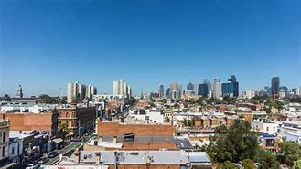Brunswick is currently known for its bohemian culture and strong arts and live music scenes. It is also home to a large student population owing to its proximity to the University of Melbourne and RMIT University. Click [here](https://www.google.com.au/maps/search/secondary+schools/@-37.7719122,144.9488645,14z/data=!4m8!2m7!3m6!1ssecondary+schools!2sBrunswick+VIC+3056!3s0x6ad65cb927b1a969:0x5045675218cd5b0!4m2!1d144.9628!2d-37.7667) to access the Google Map of the local area, highlighting Brunswick Secondary College.

The Brunswick area is very accessible via cycling and walking with major shopping and recreation areas in close proximity. Brunswick is a very bike-friendly neighbourhood, with major roads having provision for cycling lanes, and there are several major dedicated local bike paths that allow cyclists to avoid road use as much as possible. Brunswick is surrounded by fantastic suburbs: Coburg (north), Thornbury and Northcote (east) and Carlton North and Fitzroy North (south).

### 6.6.1 Shopping

|  |  |  |
| --- | --- | --- |
| **[Barkly Square](https://barklysquare.com.au/)**  1 - Barkly Square | **[Leased Shop & Retail Property at Union Square Shopping Centre, Shop 5, 190  Union Street, Brunswick West, VIC 3055 - realcommercial](https://www.localstore.com.au/store/257812/union-square-shopping-centre/brunswick-west/)**  2 - Union Square | **3 - Highpoint Shopping Centre** |
| 4 - Emporium Melbourne | **[Melbourne Central One Day Shopping Festival - Melbourne](https://www.melbournecentral.com.au/home)**  **5 - Melbourne Central** | **6 - DFO Essendon - Outlets** |

## Workplace rights and protections

International students are allowed to have part-time or casual job under their visa conditions.

It is important that you know your [visa conditions](https://immi.homeaffairs.gov.au/visas/already-have-a-visa/check-visa-details-and-conditions/see-your-visa-conditions) and your rights in the workplace before finding a part-time job. For more information, contact the Fair Work Infoline on 13 13 94 or visit [Fair Work website](https://www.fairwork.gov.au/tools-and-resources/fact-sheets/rights-and-obligations/international-students#workplace-rights).

# Studying at Brunswick Secondary College

## School term dates and holidays

The Melbourne public school year runs on the calendar year, usually begin late January and end around December 19th for the summer holidays. Students attend school for about 40 weeks per year, divided into four school terms holidays between each term typically last for two weeks. The summer holiday break is significantly longer at five to six weeks.

You can find out more about school term dates in Victoria [here](https://www.vic.gov.au/school-term-dates-and-holidays-victoria?Redirect=1).

## School timetable

Students attend school from Monday to Friday – usually from 8.45 am to 3.30 pm.

Please refer to the daily timetable sample at Brunswick below:

## School Resources

### Library

Library opens Monday – Friday from 8.30 am to 4.00 pm.

Brunswick library gives students a wide variety of books. You can also view the library’s current catalogue [here](http://library.brunswick.vic.edu.au/cataloging/servlet/handlevisualsearchdisplayform.do?nodeid=145&parentid=138&searchHistoryID=).

### Bocca Café- Online lunch order

School café is located opposite the sport ground in H block. You can register and order lunch in advance via <https://boccafoods.com.au/> or simply make your way to the Café during lunch time. The café’s menu can be viewed on your student online portal – COMPASS.

### First Aid

First Aid room is located on ground floor near the general office in A block. Students are welcome to rest in First Aid if they feel unwell.

If the injury or illness is minor, student will be treated and sent back to class.

If the injury or illness requires the student to be sent home, the student’s parent/carer will be contacted by the school’s first aid attendant for permission to go home. International student’s permission to leave need to be approval by International Student Coordinator (ISC) or legal guardian.

Brunswick Secondary College has a school doctor who visits the school every two weeks.  Students can make an appointment to see the doctor via the Student Welfare Coordinator or School Nurse.

### Uniform shop

All students are expected to wear the prescribed Brunswick Secondary College uniform and follow the school’s uniform policy. Students can either purchase new uniforms items or second-hand uniform items.

New uniforms items may be purchased at the College’s uniform shop, located in the A Block inside the Dawson Street entrance. Shop hours: Monday 8 am – 9 am and Wednesday 3 pm – 4 pm. More details about school uniform price and delivery can be found [here](https://www.dcsuniforms.com.au/collections/brunswick-secondary-college).

Second hand uniform items sales are regularly run by the BSC Parent-Association. These sales will be advertised to the school community via the Compass newsfeed throughout the year.

### Booklists & Stationary

BSC uses Campion Books to supply textbooks and stationery packs for every year level of the school.

Orders can be placed online via the [Campion website](https://www.campion.com.au/) . Please [click **here**](https://sites.google.com/education.vic.gov.au/curriculumsite/booklists) to view your year level’s booklist and order instructions.

### Lockers and padlocks

Every student is allocated a locker. You must bring your own padlock which can be purchased in Office Works, big W or Bunnings, etc… You will be shown where your locker is on your orientation day. To ensure the safety of your belongings, do not let other students know your combination. School bags and mobile phones must be stored in the locker at the beginning of the day.

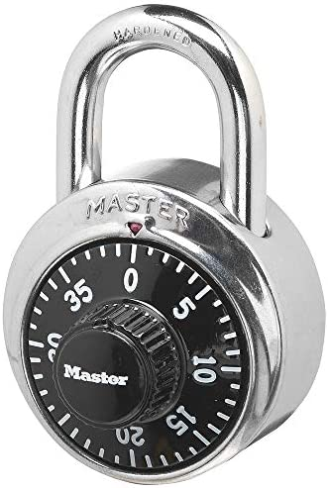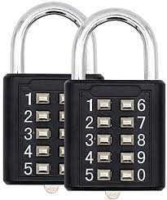

## Student Wellbeing

### Wellbeing team

At Brunswick, student wellbeing is priority across all year levels. The Wellbeing Leader works alongside a relevant Sub-School Leader, Year Level Coordinator and/or other significant staff members to ensure that individual students are supported when needed.

The Wellbeing Coordinator and their team are available to all students. Managing the Student Mentor (buddy) Program, the team initiate and execute events and activities that not only support student wellbeing, but also educate all students to take a proactive role in their personal mental health.

The Wellbeing team is located on the second floor in A block. Walk-ins are welcome and appointments can be also made in advance with our team members. Details can be found [here](https://www.brunswick.vic.edu.au/student-wellbeing/wellbeing-team/).

### Homegroups

Home group sessions have been intentionally embedded in the school timetable to support wellbeing and development of our students. Students will have one homegroup lesson weekly with their homegroup 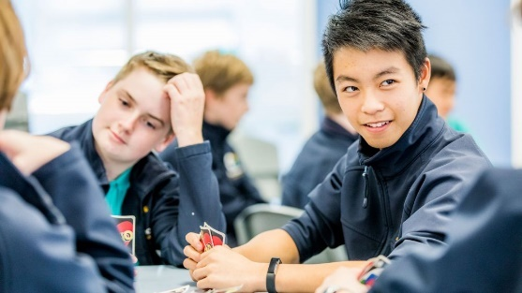teachers. Activities range from hands-on guidance and support for new students transitioning to life at BSC, right through to helping with time-management, social issues, and planning of learning pathways.

Home Group sessions provide an opportunity for promoting and maintaining a supportive environment and positive relationships for all members of the school community. Please [click here](https://www.brunswick.vic.edu.au/student-wellbeing/pastoral-care/) to find our more details about homegroups.

### Co- Curriculum Program

The Cocurricular Program is embedded into the culture of the school and is designed to support and promote student engagement, connectedness, and wellbeing.

The Brunswick Secondary College offers a dynamic range of co-curricular activities that appeal to and cater for the unique needs, talents, and interests of every student. The program runs before school, at lunchtimes and during after school sessions, offering a comprehensive range of study support groups, music, arts, and sporting activities along with more specialised interest groups.

From year to year, the Cocurricular Program adapts and changes to meet student needs. The tabs below provide  general information, but to find out more about the current activities on offer, please refer to the [BSC Co-Curricular Program](https://sites.google.com/education.vic.gov.au/bsccurriculum2023/co-curricular-program) on the BSC Curriculum website.

## Careers & Learning Pathways

A dedicated Careers Coordinator works closely with staff and students across all year levels to deliver a valuable, structured careers education program.

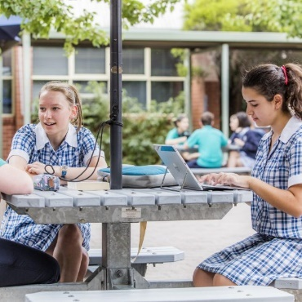Beginning in Year 7, the program encourages students to identify possible career paths based on their personal areas of interest. As they progress through to the senior year levels, students continue to revisit, reconsider, and refine this plan and can consult with the Careers Coordinator at any time to assist them in this process.

Career office is in the library. One on one appointment can be made in advance with our career counsellor via email. Please visit the Brunswick Secondary College [Careers Hub](https://careers.brunswick.vic.edu.au/)  and [Student Handbooks](https://newsletters.naavi.com/i/A5D3o1M/studentparentcarer-handbook/page/cover) to find out more about subject selection, University courses and other pathways and possibilities at BSC.

### Subject Selection

At Brunswick, we offer a program of elective subjects additionally to a core (compulsory) curriculum starting from year 9. Elective subjects enable students to specialise in areas in which they have a particular interest or talent. This flexibility promotes deeper engagement and supports higher achievement. At the same time the Elective Subjects provide excellent background to areas covered in VCE studies. Please visit [Curriculum 2023](https://sites.google.com/education.vic.gov.au/bsccurriculum2023/home) for more information.

#### Other language learning - Victoria School of Language (VSL)

At BSC, students have opportunity to learn Chinese as a Second Language and Italian as a Second Language. International students also have an opportunity to learn their first language at [Victoria School of Language (VSL)](https://www.vsl.vic.edu.au/) every Saturday morning. Language study is adjusted up to the initial VTAC scaled study score average.

#### Vocational Education and Training Program (VET)

Vocational Education and Training (VET) is learning where you develop targeted and practical skills. The skills you learn relate to a career pathway, so you can apply them at work or in further education and training. When you add a VET subject to your VCE studies, you gain practical skills in an industry in which you are interested. International Students can study VET subjects starting in Year 2023, but there are limitations. Please speak to your ISC and school Careers Counsellor for more details on VET subjects.

## School facilities

|  |  |  |
| --- | --- | --- |
| Figure 7 – Auditorium | Figure 8 - Theatre | Figure 9 - Sporting Field |
| Figure 10 - Food Technology | Figure 11 - Junior School | **Figure 12 – Gymnasium** |
| **Figure 13 – Library** | Figure 14 - Science | Figure 15 - The Green |

## School policies and documents library

On your orientation day, you will have an opportunity to go through the school policies with your ISC. Please ask your ISC if you have any questions. Students and parents are expected to follow the school’s policies. Details can be found at [Policies and Document Library - Brunswick Secondary College](https://www.brunswick.vic.edu.au/our-school/policies-documents/)

## A picture containing person Description automatically generatedA picture containing person, outdoor Description automatically generatedA picture containing person, tree, outdoor, standing Description automatically generatedThe House System

All students and staff at BSC are assigned to one of the schoolhouses – **Abyad (white), Cagaar (green), Lan Se (blue) or Oro (gold)**. Each house is assigned a House Captain.

The House System is utilised to organise students into competition groups, most notably for intraschool carnivals such as the Athletics Carnival and the Swimming Carnival.

The system is also implemented for other activities on a whole-school or year-level basis, such as wellbeing activities; House activities which are largely inspired, organised, and led by students.

The House System provides opportunity for students to develop friendships across all year levels and to exercise their leadership and teamwork skills.  In turn, this strengthens community ties, embedding and enhancing a sense of inclusion and self-worth in all participants.

## BYOD and Computer Services

### Bring your own Device (BYOD) Program

BSC is a Microsoft Education environment where we use the full range of professional Microsoft tools to enhance teaching, learning and communication. As such, it is mandatory for every student attending the college to bring a suitable Windows device to all classes. Please click [here](https://www.brunswick.vic.edu.au/learning/elearning-devices/) to learn more about device recommendations and other IT policies from our IT team.

Brunswick Secondary College has special arrangements with JB Hi-Fi that offers discounted prices for the lease or purchase of devices for Brunswick Secondary College students. Please visit [JB Hi-Fi Education](https://www.jbeducation.com.au/byod/) for more information about the purchase.

### Computer services

At orientation, the IT staff will connect the device to the wireless network providing access to network resources. Students will be provided access to a range of Microsoft products including OneDrive and Teams which allows them to store content online. Please visit our IT team located in A block if you have any technical issues with your devices.

#### Compass School Management System

[Compass](https://brunswick-vic.compass.education/) is a school management platform, enable for students and parents to engage with school activities and information. Parents and students can view their personal details, daily timetable, attendance, and learning reports via Compass. It can also be download as an app in your phone. Login details will be emailed to parents at the beginning of the school.

#### Email address

All students and teachers at BSC have an email address. Your email address will be (your[studentcode)@brunswick.vic.edu.au](mailto:studentcode@brunswick.vic.edu.au). Please check your email account regularly to keep update on school information.

#### Printing

Printers are available for students at school. Printing is not free so you will need money in your student card for printing. You can ask for the top-up at the general office when the card is out of credit.

#### Mobile phones

A ban on using mobile phones during school hours for all public-school students in Victoria started in 2020. Students are expected to securely store their mobile phones in their lockers by 8.45 am and not accessed until after school at 3.21 pm.

## Tuition fee and other payments

### Tuition fee

Your tuition invoice will be sent from International Education - Student Finance to your family/agent email. Your ISC will also send you an email for payment reminder. You will need to contact International Education - Student Finance at [isfinance@edumail.vic.gov.au](mailto:isfinance@edumail.vic.gov.au) with your full name and international student numberdirectly for any request regarding your tuition fee payment.

Please [click here](https://www.study.vic.gov.au/en/payment/Pages/default.aspx)  for payment instruction.

International Student Tuition Fees for Victorian Government Schools can be found at [Standard Tuition Fee Rate Card](https://study.vic.gov.au/Shared%20Documents/en/StandardTuition-FeeRateCard.pdf)

### VCAA

The [Victorian Curriculum and Assessment Authority (VCAA)](https://www.vcaa.vic.edu.au/Pages/HomePage.aspx) charge administration fees for a range of services. These fees apply to all students, include international students. Administration fees are for examinations, statements of marks or study scores, replacement certificates and other VCAA services.

You will receive a VCAA invoice from ISP office when you are in Year 10, Year 11 and Year 12. Please be aware that failure to pay all full-fee-paying overseas student invoices received over the period of their enrolment in the VCE program (which may be over one or more years) will result in final results being withheld from the student, the school and VTAC.

Please call or come to the front office in person to arrange the payment after you receive your invoice.

For more information, please visit [International Student Program School Fee Page](https://study.vic.gov.au/en/international-student-program/school-fees/Pages/default.aspx)

# 8. Other useful websites

### Studying in Melbourne & FAQ

[Studying in Victoria](https://www.study.vic.gov.au/en/faq/Pages/default.aspx)

[Predeparture-Guide.pdf (study.vic.gov.au)](https://www.study.vic.gov.au/Shared%20Documents/en/Predeparture-Guide.pdf)

[Study in Melbourne](https://www.studymelbourne.vic.gov.au/)

[Victorian School Terms](https://www.vic.gov.au/school-term-dates-and-holidays-victoria?Redirect=1)

### [Australian ALL IN ONE in Chinese](https://aus01.safelinks.protection.outlook.com/?url=https%3A%2F%2Fonline.fliphtml5.com%2Fbbymf%2Fwcpx%2F&data=05%7C01%7C%7C9884dd000a57421b8f4d08db57fca81a%7C6606ed36f3f34552a456597cbb23e23e%7C0%7C0%7C638200514914403822%7CUnknown%7CTWFpbGZsb3d8eyJWIjoiMC4wLjAwMDAiLCJQIjoiV2luMzIiLCJBTiI6Ik1haWwiLCJXVCI6Mn0%3D%7C3000%7C%7C%7C&sdata=fDTjAG55b7uJdJuXPTUYniB8LI9JK2N3KDgX7gbl53k%3D&reserved=0)

[Australian ALL IN ONE in English](https://aus01.safelinks.protection.outlook.com/?url=https%3A%2F%2Fonline.fliphtml5.com%2Fbbymf%2Fjgxg%2F&data=05%7C01%7C%7C9884dd000a57421b8f4d08db57fca81a%7C6606ed36f3f34552a456597cbb23e23e%7C0%7C0%7C638200514914403822%7CUnknown%7CTWFpbGZsb3d8eyJWIjoiMC4wLjAwMDAiLCJQIjoiV2luMzIiLCJBTiI6Ik1haWwiLCJXVCI6Mn0%3D%7C3000%7C%7C%7C&sdata=olHCQoyJ4rEbkxAN2keH1dQm650Xz56BUz342BU9GMs%3D&reserved=0)

### International Student Visa Condition

[Student Visa Information](https://immi.homeaffairs.gov.au/visas/getting-a-visa/visa-listing/student-500" \l "Overview)

### Melbourne life

[Visit Victoria](https://www.visitvictoria.com/)

[What’s On in Melbourne](https://whatson.melbourne.vic.gov.au/)

### Merri-bek City Council

[City](https://www.moreland.vic.gov.au/) of Merri-bek

[Timeout: A Guide to Brunswick](https://www.timeout.com/melbourne/things-to-do/brunswick-area-guide)

Student life

[Bullyingnoway](https://bullyingnoway.gov.au/)

[Naati](https://www.naati.com.au/) – Language Translation

[Brunswick Star Newsletter](https://newsletters.naavi.com/p/VJqP4N0/latest)

[National Youth Mental Health Foundation](https://headspace.org.au/)

### Child Safety

[Protect](https://www.vic.gov.au/protect)

[Australian Competition & Consumer Commission](https://www.accc.gov.au/consumers/protecting-yourself)

### Legal services (advice)

[Youth Law Australia](https://yla.org.au/)

### Children **&** PedestrianSafety

[Vic Roads Pedestrian Safety](https://www.vicroads.vic.gov.au/safety-and-road-rules/pedestrian-safety/children-and-pedestrian-safety)